

Topic test 2
Name: __________________________________

Chapter 1: Data analysis

• Time allowed: 45 minutes
• CAS calculators may be used.
• Part A: 10 multiple-choice questions (10 marks)
• Part B: 7 short-answer questions (30 marks)
• Part C: 1 analysis question (10 marks)
Part A
Multiple-choice questions
10 multiple-choice questions
1 mark each: 10 marks
Circle the correct answer.
1 Heights of students in Year 12 and Year 8 were recorded and the resulting data are summarised in the
boxplots below.
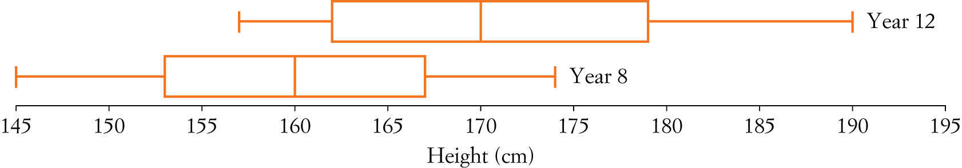
The variables ‘height’ and ‘year level’ can be classified, respectively, as:
A Continuous numerical and categorical
B Categorical and continuous numerical
C Discrete numerical and categorical
D Both numerical
E Both categorical

[1 mark]

The following information relates to Questions 2 and 3.
A school cricket coach recorded the number of runs scored per over by his team in a 35-over match. The results are shown below.
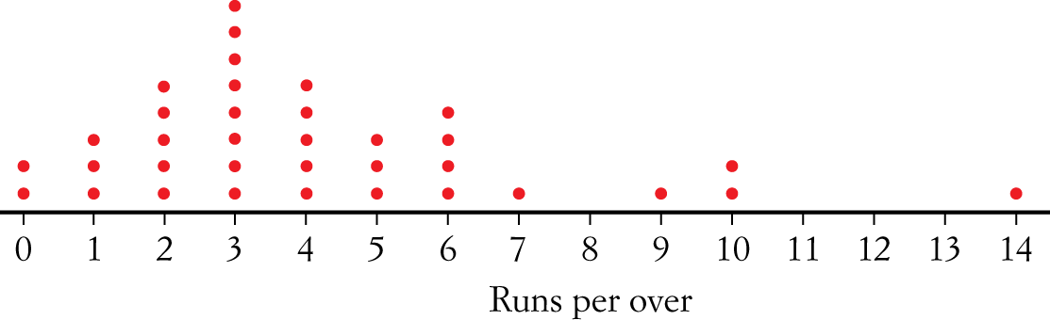
2 The total runs scored for the team was:
A 14
B 55
C 146
D 166
E 180

[1 mark]
3 The mean and median runs scored per over, respectively, are:
A 4.17 and 3.5
B 4.17 and 3
C 3 and 4.17
D 3 and 4
E 4.17 and 4

[1 mark]

The following information relates to Questions 4 and 5.
The following table resulted from a survey of smokers and non-smokers.
 | Male | Female | Total
Smokers | 202 | 130 | 332
Non-smokers | 446 | 294 | 740
Total | 648 | 424 | 1072

4 The percentage of smokers in the survey who are men is approximately:
A 42.1
B 39.6
C 39.2
D 31.2
E 12.1

[1 mark]
5 Which of the following segmented column graphs represents the survey data?
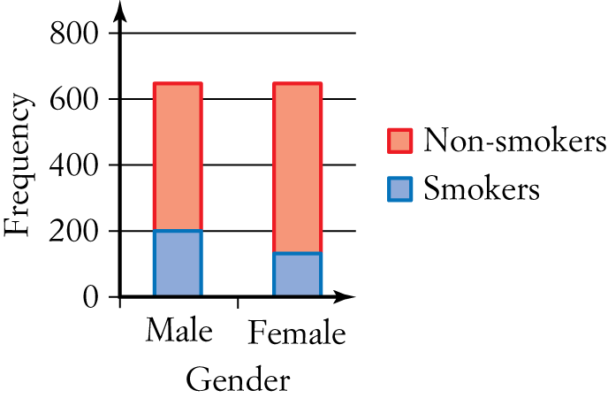  A | 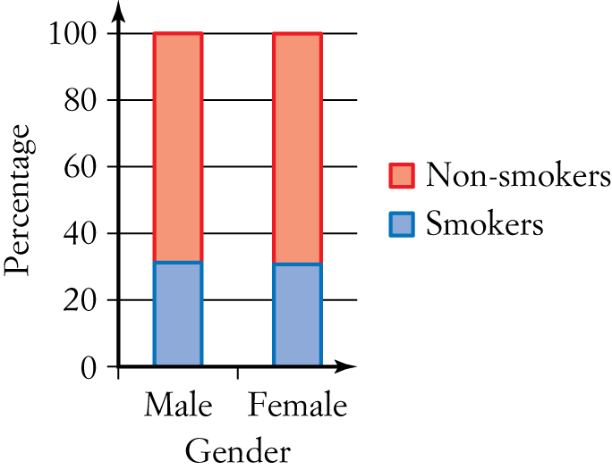  B | 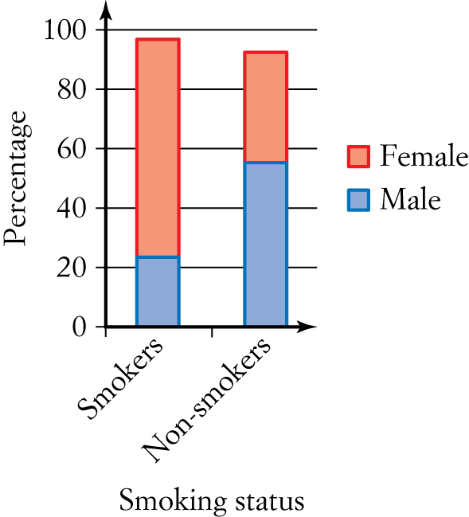  C
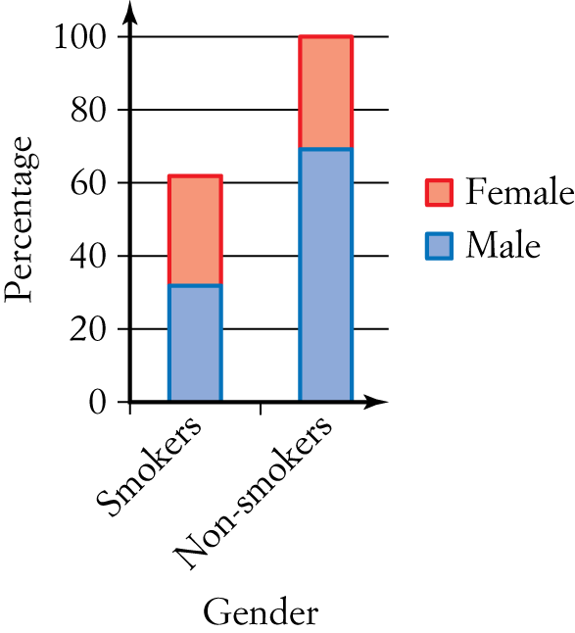  D | 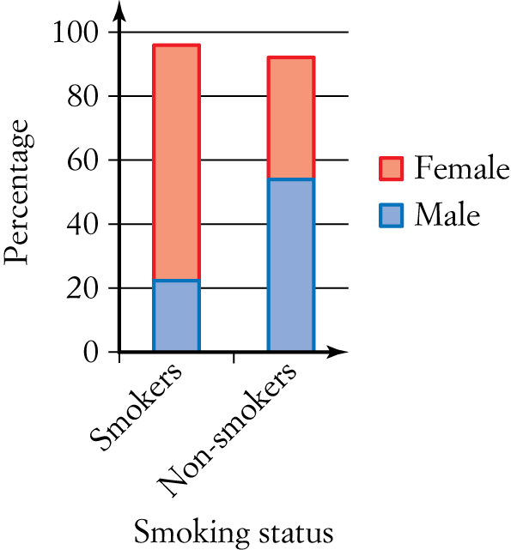  E

[1 mark]

6 The following boxplots represent the number of hours spent studying per night for three different year levels.
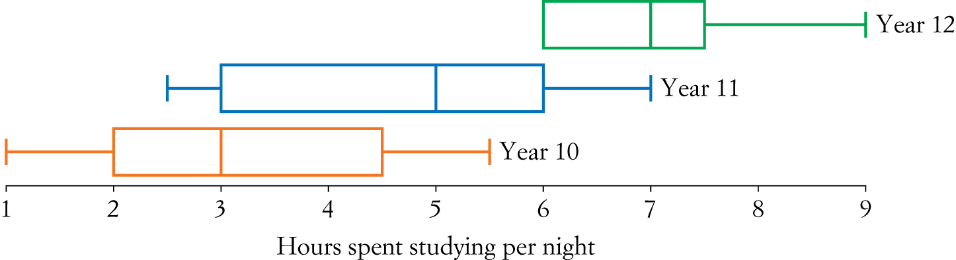
Which one of the following statements is false?
A Year 12 has the smallest interquartile range.
B All of the Year 12 students study longer than any Year 10 student.
C The range for Year 11 and Year 10 students is the same.
D The median for Year 10 is equal to the minimum amount of study time in Year 11.
E In general, as the year level increases the hours spent studying per night increases.

[1 mark]
7 Peter plays netball and cricket. The dot plot shows how many goals he scored in each netball match, whereas the stem-and-leaf plot shows the number of runs scored in each cricket innings.
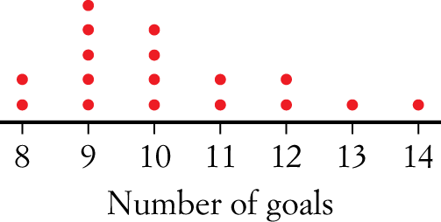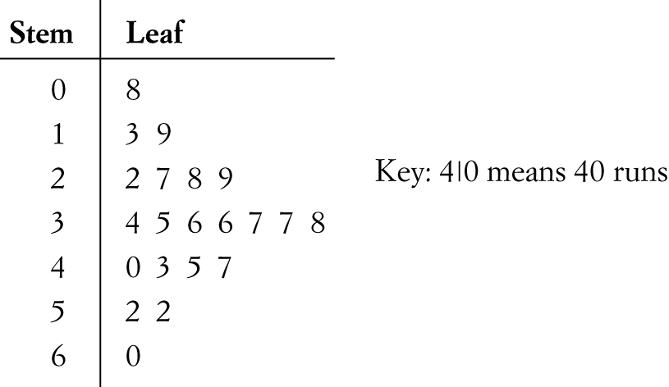
The shape of each of the graphs above is best described as:
A Both positively skewed
B Both symmetrical
C Both negatively skewed
D Positively skewed and negatively skewed
E Positively skewed and symmetrical

[1 mark]
8 Over a 12-hour period, the speed (km/h) of cyclists along a straight track is recorded, as is the speed (km/h) of the wind. The most appropriate graph to show the relationship between the speed of the cyclists and the wind speed is:
A Parallel boxplot
B Histogram
C Back-to-back stem-and-leaf plot
D Scatter plot
E Percentage segmented bar chart

[1 mark]
9 The height (in cm) and weight (in kg) of 10 students were recorded and are displayed in the scatter plot below.
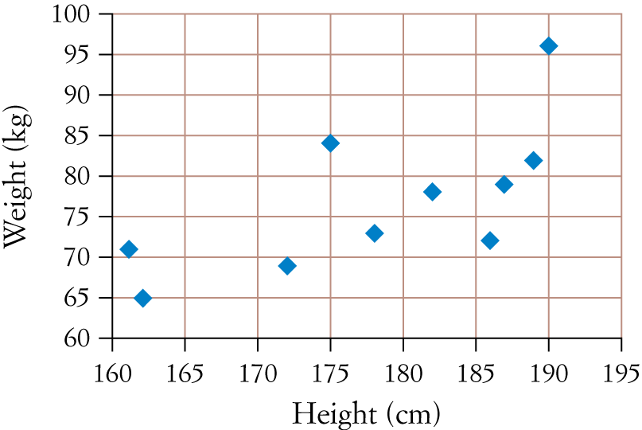
The relationship between the height and the weight of the students is best described as:
A No relationship
B Moderately negative linear relationship
C Weakly positive linear relationship
D Moderately positive non-linear relationship
E Moderately positive linear relationship

[1 mark]

10 The owner of a pizza shop chain Quix Pizza wanted to test the efficiency of delivery times. She recorded delivery times (in min) for 600 deliveries made on a Saturday night and displayed them using both a histogram and a boxplot.
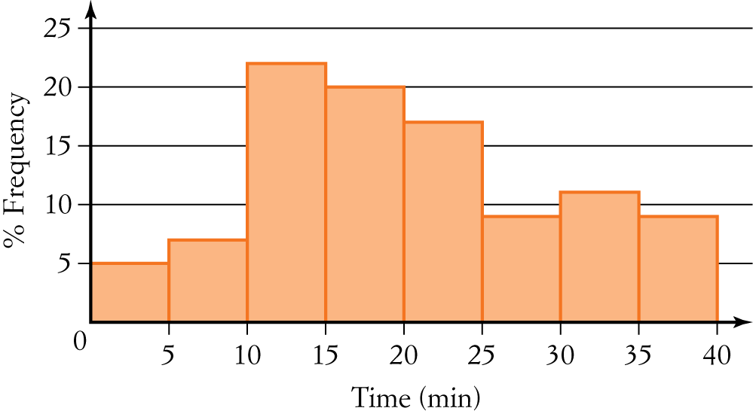
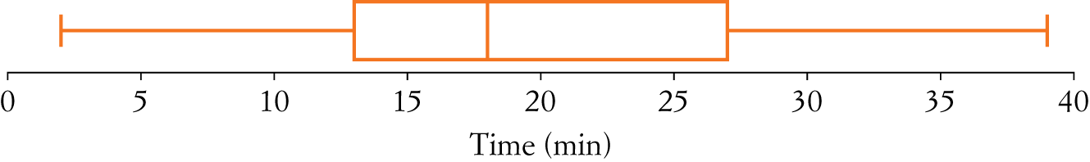
Of the 600 delivery times, how many lie between 13 minutes and 27 minutes?
A 25
B 50
C 75
D 100
E 300

[1 mark]

Part B
Short-answer questions
7 short-answer questions
30 marks
Show your working where appropriate.
1 The histogram below shows the distribution of the mean maximum temperatures for December in Melbourne for the last 55 years.
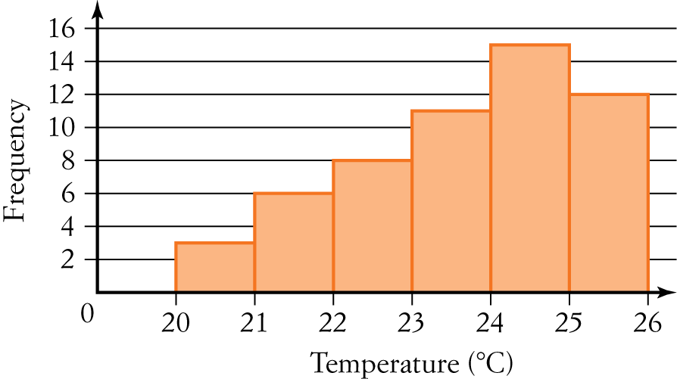
a Describe the shape of the histogram.

b Use the histogram to determine:
i the number of times the December mean maximum temperature was 238C or above

ii the percentage of times the December mean maximum temperature was between 218C and 248C. Write your answer correct to one decimal place.

[3 marks]
2 The table below shows some information about car accidents in Australia. It shows the percentage of car accidents by type of road being driven on, for three different age groups.
Type of road | Age of driver in car accident
Type of road | 18 to 30 years | 31 to 50 years | Over 50 years
Inner city | 42% | 50% | 16%
Country | 33% | 32% | 50%
Freeway | 25% | 18% | 34%

a Of the car accidents involving drivers over 50 years of age, what percentage occurred on country roads or freeways?

b Does the information in the table support the opinion that the age of drivers in car accidents is associated with the type of road on which they were driving? Justify your answer by quoting appropriate percentages from one age group only.

[3 marks]
3 The stem-and-leaf plot below shows the ages of visitors entering the Royal Easter Show in a 5-minute period.
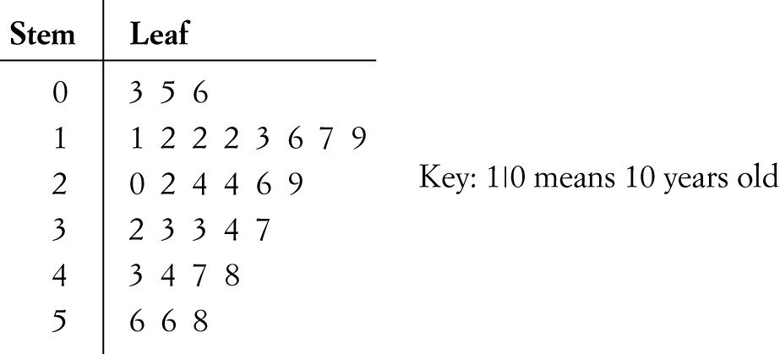
a How many visitors entered the show during the 5-minute period?

b What was the age of the oldest visitor?

c What was the most common age?

d What percentage of the visitors was under 22 years old? State your answer correct to one decimal place.

e What was the average age of the visitors? State your answer correct to two decimal places.

[5 marks]

4 The dot plot below shows the shoe sizes of a group of 12-year-old boys from a Year 6 class.
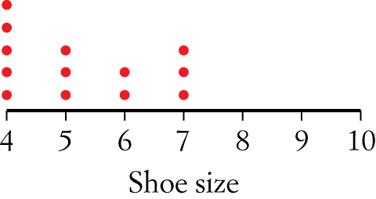
a Calculate the median shoe size.

b Calculate the mean shoe size, correct to one decimal place.

Peter was absent on the day the data were collected. He has a shoe size of 10.
c Add Peter’s shoe size as a data point on the dot plot.
d With the addition of Peter’s shoe size, does the median, mean, or both, change? Justify your answer with appropriate working.

[5 marks]
5 For the following sets of variables, state which is the explanatory variable and which is the response variable.
a Height of trees and age of trees.

b Value of a house and the suburb in which it is located.
[2 marks]
6 The number of hours spent playing computer games each week and gender were recorded for a group
of children aged 14 years. The results are shown below.
Gender | Time (h) | Gender | Time (h) | Gender | Time (h) | Gender | Time (h)
Female | 7 | Male | 11 | Female | 1 | Female | 12
Male | 24 | Female | 5 | Female | 6 | Female | 12
Female | 23 | Male | 33 | Male | 41 | Male | 12
Male | 31 | Female | 17 | Female | 8 | Female | 20
Female | 8 | Male | 10 | Female | 12 | Female | 3
Female | 10 | Female | 9 | Male | 21 | Male | 15
Male | 22 | Male | 35 | Male | 43 | Female | 13

a Construct a back-to-back stem-and-leaf plot to represent the above data.

b Describe the shape of the data for each gender.

c Calculate the mean amount of time spent playing computer games for each gender, correct to two decimal places.

d Does the data support the statement ‘Gender is associated with the amount of time spent playing computer games for children aged 14 years'? Justify your answer.

[8 marks]
7 The length (l mm) of a metal bar was measured at various temperatures (t °C) to give the following results.
t °C | 105 | 108 | 110 | 115 | 117 | 120 | 122 | 125 | 130 | 135
l mm | 20.1 | 20.5 | 20.8 | 21.8 | 21.9 | 22.0 | 22.9 | 24.6 | 25.7 | 26.0

a Complete the following scatter plot by adding the last three points shown in bold in the table.
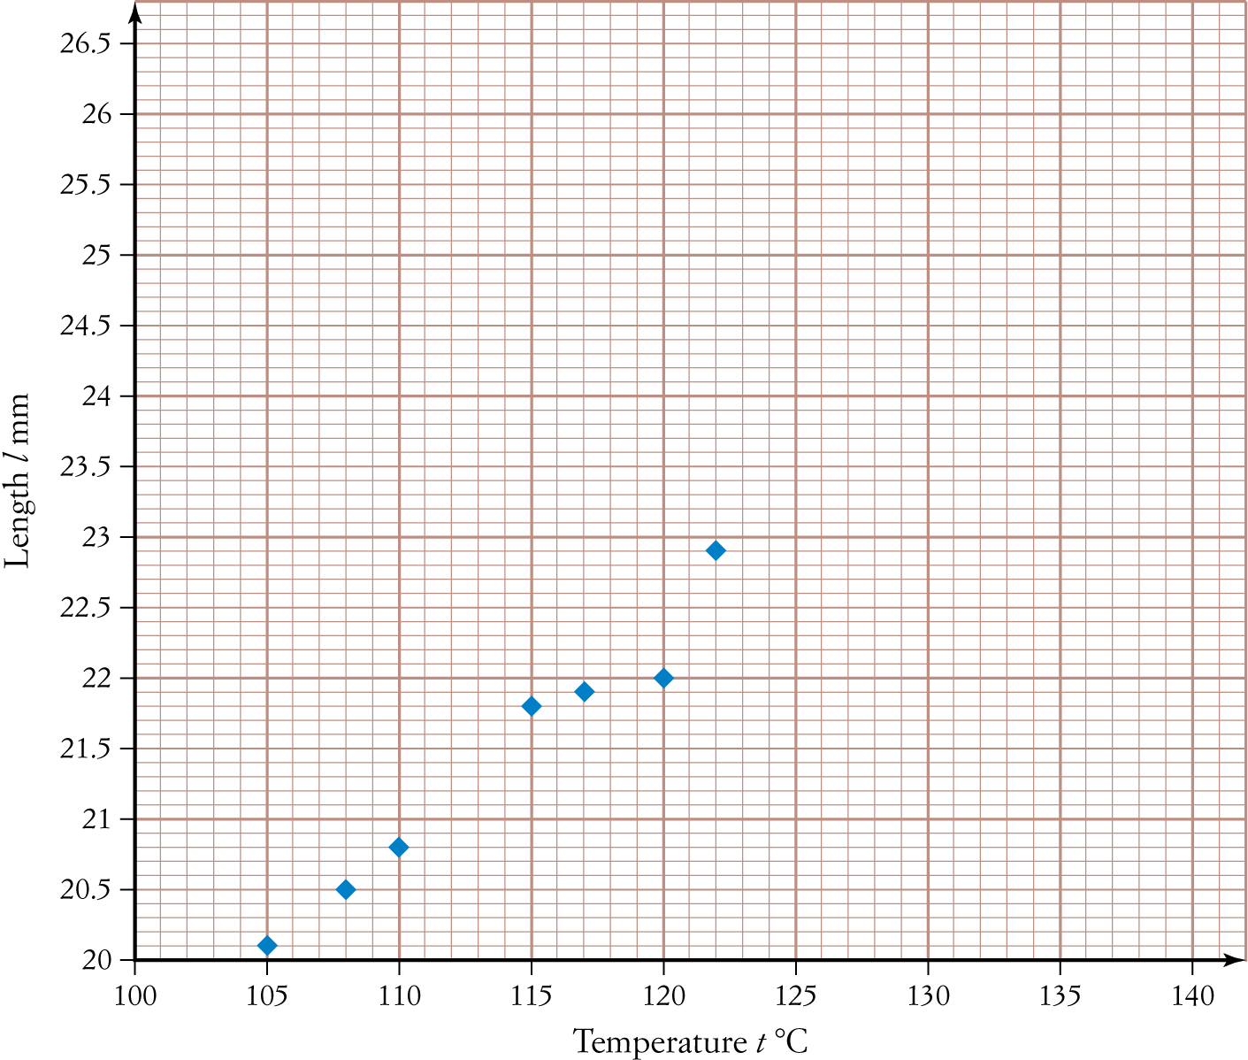
b Calculate Pearson’s correlation coefficient for the data, correct to two decimal places.

c Interpret the relationship between the variables ‘Length’ and ‘Temperature’, referring to form, direction
and strength.

[4 marks]

Part C
Analysis question
1 analysis question
10 marks
Show your working where appropriate.
1 CensusAtSchool asked students in different year levels to measure the height of their belly button from the floor, to the nearest cm, when standing. The results for Years 9, 10 and 11 students are displayed in the parallel boxplots below.

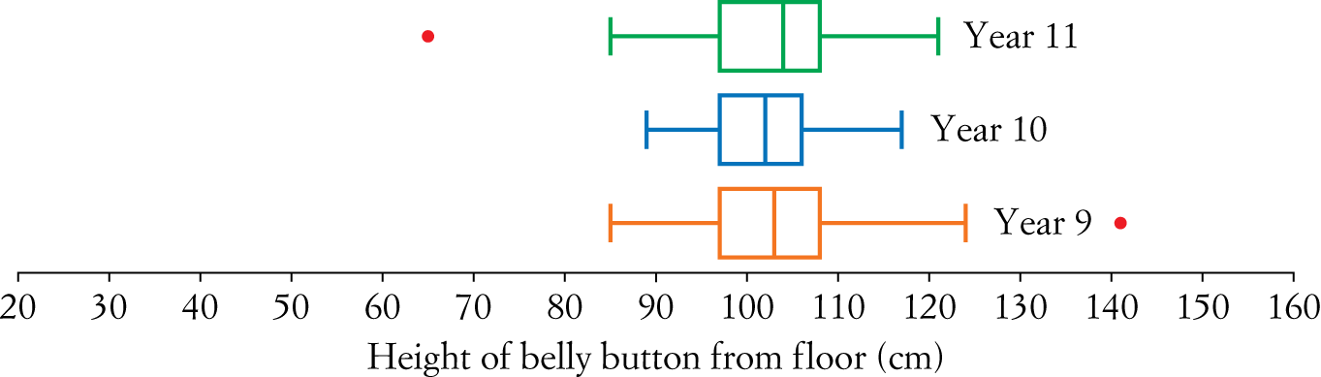
a Which five-summary statistic is the same for all three year levels?

b Which year level has the greatest spread of belly button heights?

c The belly button height of 65 cm is an outlier in the Year 11 data. Formally show why this is the case, knowing that Q₁ = 97 and Q₃ = 108.

d Is there an association between year level and height of belly buttons from the floor?

The same data were also collected for a small group of Year 12 students and are listed below.
90 100 108 110 23 55 90 109 111
e State the five-number summary for the Year 12 students.

f Hence, add the Year 12 data to the parallel boxplots for Years 9 to 11.
g Complete the following statement by circling the correct bold responses.

The belly button heights of Year 12 students are generally greater/less than those of students in Year 9 and are more/less variable.
[10 marks]
[ Total marks: 50]
Answers
Part A – Multiple-choice questions [1 mark each]
1 Height is a measurement, so the data are numerical and continuous, and Year level is categorical.
∴ A
2 Add up all the runs.
Runs 0 + 3 + 10 + 24 + 20 + 15 + 24 + 7 + 9 + 20 + 14 = 146
∴ C
3 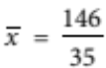≈ 4.17; median position is the 18th dot, which is a 3.
∴ B
4 Percentage of male smokers 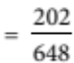 × 100% ≈ 31.2%.
∴ D
5 Convert table to a percentage two-way table.
 | Male | Female
Smokers | 31.2% | 30.7%
Non-smokers | 68.8% | 69.3%
Total | 100% | 100%
Match to segmented graph, ensuring the x-axis is labelled ‘Gender’.
∴ B
6 A True, as Year 12 has the smallest box section.
B True, as Year 10 maximum is 5.5 and Year 12 minimum is 6.
C True, as both have a range of 4.5.
D False, as Year 10 median is 10 and Year 11 minimum is 2.5.
E True, as the median increases as the year level increases.
∴ D
7 Dot plot is positively skewed and stem-and-leaf plot is symmetrical.
∴ E
8 Speed of cyclists and wind speed are both numerical variables. Therefore, a scatter plot is the most appropriate graph.
∴ D
9 Weight increases as height increases; therefore, there is a positive linear relationship and the spacing
of the dots indicates moderate strength.
∴ E
10 Between 13 minutes and 27 minutes represents 50% of the data, and 50% of 600 is 300.
∴ E
Part B – Short-answer questions
1 a Negatively skewed [1 mark]
b i 11 + 15 +12 = 38 times [1 mark]
ii 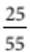 × 100% ≈ 45.5% [1 mark]
2 a 50% + 34% = 84% [1 mark]
b Yes, they are associated. [1 mark] This is supported by the 18–30-year-old age group who had 42% of accidents on inner city roads, 33% on country roads and 25% on freeways. [1 mark] (Students may refer to the other age groups, as the answer does not have to refer only to the 18–30 year olds.)
3 a 29, count each number in the leaf [1 mark]
b 58 years, read largest value from plot [1 mark]
c 12 years, as it appears the most [1 mark]
d 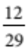 × 100% ≈ 41.4% [1 mark]
e 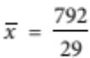≈ 27.31 years old [1 mark]
4 a Position of the median is the 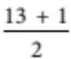th = 7th dot, which is a 5. [1 mark]
b 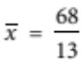≈ 5.2% [1 mark]
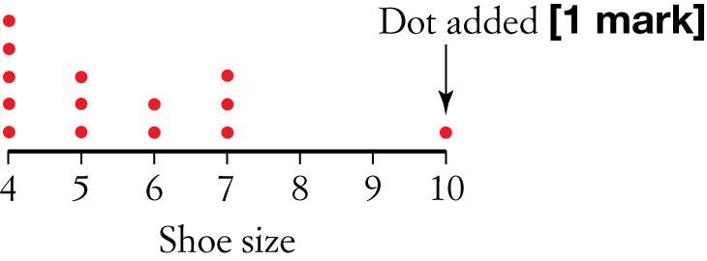
c

d Median will stay the same, as its position will be between the 7th and 8th dots, which are both 5. [1 mark]
Mean will change, as calculation becomes 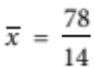 ≈ 5.6. [1 mark]
5 a EV = age of tree, RV = height of tree [1 mark]
b EV = suburb in which house is located, RV = value of house [1 mark]
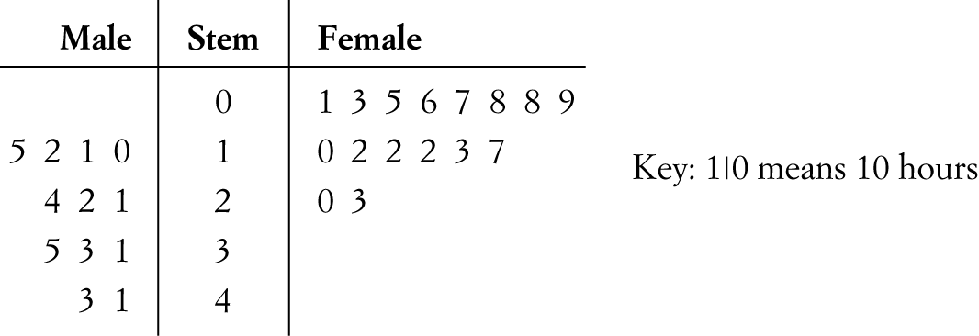
6 a

[3 marks – 1 mark for male, 1 mark for female and 1 mark for key]
b Both positively skewed [1 mark]

c Using CAS, male = ≈ 24.83 h [1 mark] and female = ≈ 10.38 h [1 mark].
d Yes, the amount of time spent playing computer games may be associated with gender [1 mark], as the mean for males is much higher than that for females [1 mark].
7 a Check the scatter plot and ensure points have been added for the following coordinates: (125, 24.6), (130, 25.7) and (135, 26.0). [1 mark]
b Using CAS, r = 0.97. [1 mark]
c Strong positive linear relationship; [1 mark] therefore, it can be concluded that the length of the metal bar increases as the temperature increases [1 mark].
Part C – Analysis question
1 a Quartile 1 or Q₁ [1 mark]
b Year 9, as it has the largest range. [1 mark]
c 97 − 1.5 × 11 ≤ x ≤ 108 + 1.5 × 11
80.5 ≤ x ≤ 124.5 [1 mark]. Therefore, 65 is an outlier, as it is smaller than 80.5 [1 mark].
d There is no association, as the graphs are very similar, particularly the medians. [1 mark]
e Using CAS will give the results shown in the table below.
[1 mark for two correct, 2 marks for all correct]
Minimum | 23
Q1 | 72.5
Median | 100
Q3 | 109.5
Maximum | 111

f Check parallel boxplots and make sure that the Year 12 boxplot is constructed using the answers found in part e. The boxplot must be labelled ‘Year 12’ to get full marks. [1 mark]
g Circle ‘less’ [1 mark] and ‘more’ [1 mark].
The belly button heights of Year 12 students are generally less than those of students in Year 9 and are
more variable.

